**TABLE OF CONTENTS**

**CHAPER PAGE**

**NO. TITLE NO.**

**ABSTRACT**

**LIST OF FIGURES**

**LIST OF TABLES**

1. **INTRODUCTION**

* 1. **GRINDING**

* 1. **PROCESS**
     1. **CREEP-FEED GRINDING**
     2. **HIGH-EFFICIENCY DEEP GRINDING**
     3. **ULTRA-HIGH SPEED GRINDING**

**1.3 TYPES OF GRIDING**

**1.3.1 SURFACE GRINDING**

**1.3.2 CYLINDRICAL GRINDING**

**1.3.3 INTERNAL GRINDING**

**1.3.4 CENTERLESS GRINDING**

**1.3.5 CONTOUR GRINDING**

**1.3.6 GEAR GRINDING**

* + 1. **THREAD GRINDING**

**1.4 BENCH GRINDING**

**1.4.1 TYPES OF BENCH GRINDING**

**1.4.2**

**1.4.3**

**1.4.4 ADVANTAGE & DIS-ADVANTAGE**

**INTRODUCTION**

**What is grinding**

**Grinding is a type of**[**abrasive machining**](https://en.wikipedia.org/wiki/Abrasive_machining)**process which uses a**[**grinding wheel**](https://en.wikipedia.org/wiki/Grinding_wheel)**as**[**cutting tool**](https://en.wikipedia.org/wiki/Cutting_tool_(machining))**.**

**A wide variety of machines are used for grinding, best classified as portable or stationary:**

* **Portable**[**power tools**](https://en.wikipedia.org/wiki/Power_tool)**such as**[**angle grinders**](https://en.wikipedia.org/wiki/Angle_grinder)**,**[**die grinders**](https://en.wikipedia.org/wiki/Die_grinder)**and**[**cut-off saws**](https://en.wikipedia.org/wiki/Abrasive_saw)
* **Stationary**[**power tools**](https://en.wikipedia.org/wiki/Power_tool)**such as**[**bench grinders**](https://en.wikipedia.org/wiki/Bench_grinder)**and**[**cut-off saws**](https://en.wikipedia.org/wiki/Abrasive_saw)
* **Stationary**[**hydro-**](https://en.wikipedia.org/wiki/Hydropower)**or**[**hand-powered**](https://en.wikipedia.org/wiki/Human_power)[**sharpening stones**](https://en.wikipedia.org/wiki/Grindstone_(tool))

**Milling practice is a large and diverse area of**[**manufacturing**](https://en.wikipedia.org/wiki/Manufacturing)**and [toolmaking](https://en.wikipedia.org/wiki/Tool_and_die_maker" \o "Tool and die maker). It can produce very fine finishes and very accurate dimensions; yet in mass production contexts, it can also rough out large volumes of metal quite rapidly. It is usually better suited to the machining of very**[**hard**](https://en.wikipedia.org/wiki/Hardness)**materials than is "regular" machining (that is, cutting larger chips with cutting tools such as**[**tool bits**](https://en.wikipedia.org/wiki/Tool_bit)**or**[**milling cutters**](https://en.wikipedia.org/wiki/Milling_cutter)**), and until recent decades it was the only practical way to machine such materials as hardened steels. Compared to "regular" machining, it is usually better suited to taking very shallow cuts, such as reducing a shaft's diameter by half a**[**thousandth of an inch**](https://en.wikipedia.org/wiki/Thousandth_of_an_inch)**or 12.7 [μm](https://en.wikipedia.org/wiki/Micrometre" \o "Micrometre).**

**Grinding is a subset of cutting, as grinding is a true metal-cutting process. Each grain of abrasive functions as a microscopic single-point cutting edge (although of high negative**[**rake angle**](https://en.wikipedia.org/wiki/Rake_angle)**), and shears a tiny chip that is analogous to what would conventionally be called a "cut" chip (turning, milling, drilling, tapping, etc.)[**[***citation needed***](https://en.wikipedia.org/wiki/Wikipedia:Citation_needed)**]. However, among people who work in the machining fields, the term *cutting* is often understood to refer to the macroscopic cutting operations, and *grinding* is often mentally categorized as a "separate" process. This is why the terms are usually used separately in shop-floor practice.**

[**Lapping**](https://en.wikipedia.org/wiki/Lapping)**and**[**sanding**](https://en.wikipedia.org/wiki/Sandpaper)**are subsets of grinding.**

**Processes**

**Selecting which of the following grinding operations to be used is determined by the size, shape, features and the desired production rate.**

**Creep-feed grinding**

**(CFG) was a grinding process which was invented in Germany in the late 1950s by Edmund and Gerhard Lang. Normal grinding is used primarily to finish surfaces. But CFG is used for high rates of material removal, competing with milling and turning as a manufacturing process choice. CFG has grinding depth up to 6 mm (0.236 inches) and workpiece speed is low. Surfaces with a softer-grade resin bond are used to keep workpiece temperature low and an improved surface finish up to 1.6 μm Rmax.**

**CFG can take 117**[**s**](https://en.wikipedia.org/wiki/Second)**to remove 1 in3 (16 cm3) of material. Precision grinding would take more than 200 s to do the same. CFG has the disadvantage of a wheel that is constantly degrading, requires high spindle power (51 hp or 38 kW), and is limited in the length of part it can machine.**

**To address the problem of wheel sharpness, continuous-dress creep-feed grinding (CDCF) was developed in 1970s. The wheel is dressed constantly during machining in CDCF process and keeps the wheel in a state of specified sharpness. It takes only 17 s to remove 1 in3 (16 cm3) of material, a huge gain in productivity. 38 hp (28 kW) spindle power is required, with a low to conventional spindle speeds. The limit on part length was erased.**

**High-efficiency deep grinding (HEDG) is another type of grinding. This process uses plated superabrasive wheels. These wheels never need dressing and last longer than other wheels. This reduces capital equipment investment costs. HEDG can be used on long part lengths and removes material at a rate of 1 in3 (16 cm3) in 83 s. HEDG requires high spindle power and high spindle speeds.**

**Peel grinding, patented under the name of Quickpoint in 1985 by**[**Erwin Junker**](https://en.wikipedia.org/wiki/Erwin_Junker)**Maschinenfabrik, GmbH in Nordrach, Germany, uses a thin superabrasive grinding disk oriented almost parallel to a cylindrical workpiece and operates somewhat like a lathe turning tool.**

**Ultra-high speed grinding (UHSG) can run at speeds higher than 40,000 fpm (200 m/s), taking 41 s to remove 1 in3 (16 cm3) of material, but is still in the research and development (R&D) stage. It also requires high spindle power and high spindle speeds.**

**Various grinding methods**

* **Surface grinding. ...**
* **Cylindrical grinding. ...**
* **Internal grinding. ...**
* **Centerless grinding. ...**
* **Contour grinding. ...**
* **Gear grinding. ...**
* **Thread grinding.**

### Cylindrical grinding

**Cylindrical grinding is often called Enken, using either a cylindrical grinding machine or a universal grinding machine.**

**Both the cylindrical workpiece and the wheel are rotated and the outer periphery of the workpiece is machined.**

**The various grinding methods include straight cylindrical, taper, end face, and total shape grinding.**

**Similar to surface grinding, it is a general grinding method in wide use.**

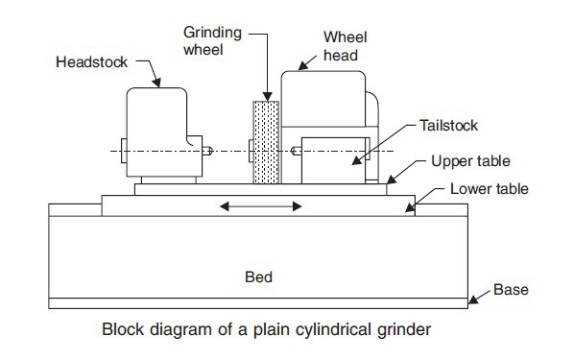

**Cylindrical grinding (also called center-type grinding) is used to grind the cylindrical surfaces and shoulders of the workpiece. The workpiece is mounted on [centers](https://en.wikipedia.org/wiki/Lathe_center" \o "Lathe center) and rotated by a device known as a**[**lathe dog**](https://en.wikipedia.org/wiki/Lathe_dog)**or center driver. The abrasive wheel and the workpiece are rotated by separate motors and at different speeds. The table can be adjusted to produce tapers. The wheel head can be swiveled. The five types of cylindrical grinding are: outside diameter (OD) grinding, inside diameter (ID) grinding, plunge grinding, creep feed grinding, and centerless grinding.**

**A**[**cylindrical grinder**](https://en.wikipedia.org/wiki/Cylindrical_grinder)**has a grinding (abrasive) wheel, two centers that hold the workpiece, and a chuck, grinding dog, or other mechanism to drive the work. Most cylindrical grinding machines include a swivel to allow the forming of tapered pieces. The wheel and workpiece move parallel to one another in both the radial and longitudinal directions. The abrasive wheel can have many shapes. Standard disk-shaped wheels can be used to create a tapered or straight workpiece geometry, while formed wheels are used to create a shaped workpiece. The process using a formed wheel creates less vibration than using a regular disk-shaped wheel.**

**Tolerances for cylindrical grinding are held within ±0.0005 inches (13 μm) for diameter and ±0.0001 inches (2.5 μm) for roundness. Precision work can reach tolerances as high as ±0.00005 inches (1.3 μm) for diameter and ±0.00001 inches (0.25 μm) for roundness.**[**Surface finishes**](https://en.wikipedia.org/wiki/Surface_finish)**can range from 2 microinches (51 nm) to 125 microinches (3.2 μm), with typical finishes ranging from 8 to 32 microinches (0.20 to 0.81 μm).**

### Surface grinding

**Surface grinding is generally called Heiken or Hiraken, which uses either a vertical axis grinding machine or a horizontal axis grinding machine, with a square table or a circular table, and a straight type wheel or a cup type wheel.**

**The workpiece is fixed on a table and the wheel is rotated at high speed to perform grinding. The double-ended type is equipped with wheels above and below to perform grinding the workpiece in between. Surface grinding is the most common grinding method and is used in a wide range of fields.**

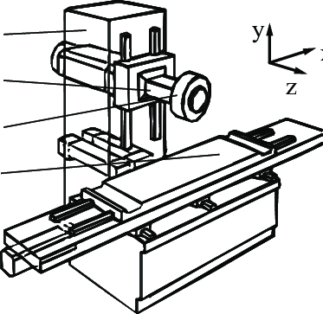

***Surface grinding* uses a rotating abrasive wheel to remove material, creating a flat surface. The tolerances that are normally achieved with grinding are ±2×10−4 inches (5.1 μm) for grinding a flat material and ±3×10−4 inches (7.6 μm) for a parallel surface.**

**The surface grinder is composed of an abrasive wheel, a workholding device known as a**[**chuck**](https://en.wikipedia.org/wiki/Chuck_(engineering))**, either electromagnetic or vacuum, and a reciprocating table.**

**Grinding is commonly used on**[**cast iron**](https://en.wikipedia.org/wiki/Cast_iron)**and various types of**[**steel**](https://en.wikipedia.org/wiki/Steel)**. These materials lend themselves to grinding because they can be held by the magnetic chuck commonly used on grinding machines and do not melt into the cutting wheel, clogging it and preventing it from cutting. Materials that are less commonly ground are [aluminum](https://en.wikipedia.org/wiki/Aluminum" \o "Aluminum),**[**stainless steel**](https://en.wikipedia.org/wiki/Stainless_steel)**,**[**brass**](https://en.wikipedia.org/wiki/Brass)**, and**[**plastics**](https://en.wikipedia.org/wiki/Plastic)**. These all tend to clog the cutting wheel more than steel and cast iron, but with special techniques it is possible to grind them.**

### Internal grinding

**Internal grinding is also called Naiken, using an internal grinding machine or a cylindrical grinding machine, or internal grinding equipment attached to a universal grinding machine.**

**The workpiece is fixed and the inner surface of the workpiece is machined with the rotating axle wheel. Grinding may sometimes be performed by rotating the workpiece. Similar to the cylindrical grinding, the grinding method includes taper and end face grinding.**

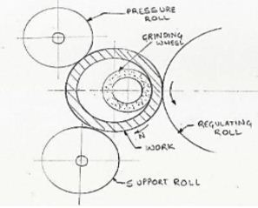

**Internal grinding is used to grind the internal diameter of the workpiece. Tapered holes can be ground with the use of internal grinders that can swivel on the horizontal.**

### Centerless grinding

**Centerless grinding is also called Shinnashi grinding, and processes the outer periphery of a cylindrical workpiece using a centerless grinding machine. A workpiece is supported between a fixed blade and a rotating adjusting wheel and a grinding wheel. The rotation and feed of the workpiece are then adjusted by rotation of the adjusting wheel to grind the outer circumference of the workpiece. Centerless grinding requires neither a center hole in the workpiece nor the workpiece’s installation on and removal from the grinding machine. These advantages make it suitable for mass production.**

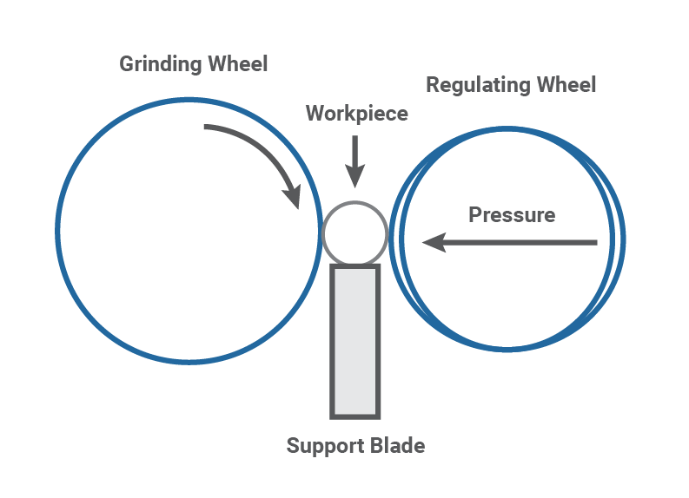

**when the workpiece is supported by a blade instead of by centers or chucks. Two wheels are used. The larger one is used to grind the surface of the workpiece and the smaller wheel is used to regulate the axial movement of the workpiece. Types of centerless grinding include through-feed grinding, in-feed/plunge grinding, and internal centerless grinding.**

### Contour grinding

**Contour grinding is also called Narai grinding, a process that machines a workpiece into an arbitrary shape using a profile grinding machine, etc.**

### Gear grinding

**Gear grinding is also called Haken, a process of shaping teeth such as gears using a gear grinding machine. General whetstones are mainly used, which are molded with the dresser (rotary dresser) using diamond abrasive grains.**

### Thread grinding

**Thread grinding is a process of forming the thread using a teeth thread grinding machine.**

**Others:**

[**Electrochemical grinding**](https://en.wikipedia.org/wiki/Electrochemical_grinding)**is a type of grinding in which a positively charged workpiece in a conductive fluid is eroded by a negatively charged grinding wheel. The pieces from the workpiece are dissolved into the conductive fluid.**

**­­­­­­­**

**Electrolytic in-process dressing (ELID) grinding is one of the most accurate grinding methods. In this ultra precision grinding technology the grinding wheel is dressed electrochemically and in-process to maintain the accuracy of the grinding. An ELID cell consists of a metal bonded grinding wheel, a cathode electrode, a pulsed DC power supply and electrolyte. The wheel is connected to the positive terminal of the DC power supply through a carbon brush whereas the electrode is connected to the negative pole of the power supply. Usually alkaline liquids are used as both electrolytes and coolant for grinding. A nozzle is used to inject the electrolyte into the gap between wheel and electrode. The gap is usually maintained to be approximately 0.1mm to 0.3 mm. During the grinding operation one side of the wheel takes part in the grinding operation whereas the other side of the wheel is being dressed by electrochemical reaction. The dissolution of the metallic bond material is caused by the dressing which in turns results continuous protrusion of new sharp grits.**

**Form grinding is a specialized type of cylindrical grinding where the grinding wheel has the exact shape of the final product. The grinding wheel does not traverse the workpiece.**

**Pre-grinding - When a new tool has been built and has been heat-treated, it is pre-ground before welding or hardfacing commences. This usually involves grinding the outside diameter (OD) slightly higher than the finish grind OD to ensure the correct finish size.**

**What is bench grinder**

# 

**A bench grinder is a [benchtop](https://en.wikipedia.org/wiki/Workbench" \o "Workbench) type of**[**grinding machine**](https://en.wikipedia.org/wiki/Grinding_machine)**used to drive**[**abrasive wheels**](https://en.wikipedia.org/wiki/Grinding_wheel)**. A pedestal grinder is a similar or larger version of grinder that is mounted on a**[**pedestal**](https://en.wiktionary.org/wiki/pedestal#Noun)**, which may be bolted to the floor or may sit on**[**rubber feet**](https://en.wikipedia.org/wiki/Bushing_(isolator))**. These types of grinders are commonly used to hand**[**grind**](https://en.wikipedia.org/wiki/Grinding_(abrasive_cutting))**various**[**cutting tools**](https://en.wikipedia.org/wiki/Cutting_tool_(machining))**and perform other rough grinding.**[**[1]**](https://en.wikipedia.org/wiki/Bench_grinder#cite_note-KrarEtAl2003-1)

**Depending on the bond and grade of the grinding wheel, it may be used for sharpening cutting tools such as**[**tool bits**](https://en.wikipedia.org/wiki/Tool_bit)**,**[**drill bits**](https://en.wikipedia.org/wiki/Drill_bit)**,**[**chisels**](https://en.wikipedia.org/wiki/Chisel)**, and**[**gouges**](https://en.wikipedia.org/wiki/Chisel#Gouge)**. Alternatively, it may be used to roughly shape metal prior to**[**welding**](https://en.wikipedia.org/wiki/Welding)**or fitting.**

**A**[**wire brush**](https://en.wikipedia.org/wiki/Wire_brush)**wheel or buffing wheels can be interchanged with the grinding wheels in order to clean or**[**polish**](https://en.wikipedia.org/wiki/Polishing_(metalworking))**workpieces. Stiff buffing wheels can also be used when [deburring](https://en.wikipedia.org/wiki/Burr_(edge)" \l "Deburring" \o "Burr (edge)) is the task at hand. Some buffing machines (buffers) are built on the same concept as bench grinders except for longer housings and arbors with buffing wheels instead of grinding wheels.**

**Bench grinders are standard equipment in**[**metal fabrication shops**](https://en.wikipedia.org/wiki/Metal_fabrication)**and**[**machine shops**](https://en.wikipedia.org/wiki/Machine_shop)**, as are handheld grinders (such as**[**angle grinders**](https://en.wikipedia.org/wiki/Angle_grinder)**and**[**die grinders**](https://en.wikipedia.org/wiki/Die_grinder)**).**

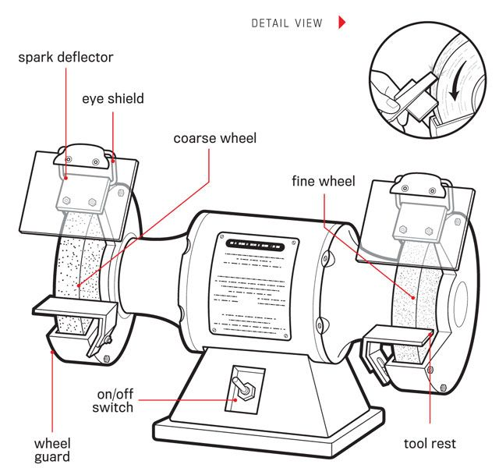

### Advantages of Grinding operation:

* **This can produce a high surface finish with accurate can obtain.**
* **This can machine hard materials.**
* **This operation can be done with less pressure applied on work.**
* **It can obtain highly accurate dimensions.**
* **It can work at high temperature also.**
* **Speed of cutting can be done by this process.**
* **In grinding abrasive particles, they are self-sharpened action.**
* **This can operate for complex things also.**
* **Smooth surface can obtain**

### Disadvantages of Grinding Operations:

* **Required tool is high cost.**
* **Process is also a costly one.**
* **It cannot remove the high amount of material, it only removes a little amount.**
* **For removing the required amount from work it consumes more time.**
* **You should work carefully, because imperfect contact may lead to damages.**